Experiment 01: Creating a Kanban Board to Visualize Tasks
Aim
To create a Kanban Board for visualizing project tasks using three workflow stages: To Do, In Progress, and Done, and to simulate task movement across these stages.
Software/Tool Required
Jira (Kanban tool)
Procedure
Step 1: Open Jira
- Open Google Chrome.
- In the address bar, type: https://www.atlassian.com/software/jira
- Press Enter.
- Click Sign In.
- Enter your Atlassian email and password.
- Click Log In.
- Click go to JIRA
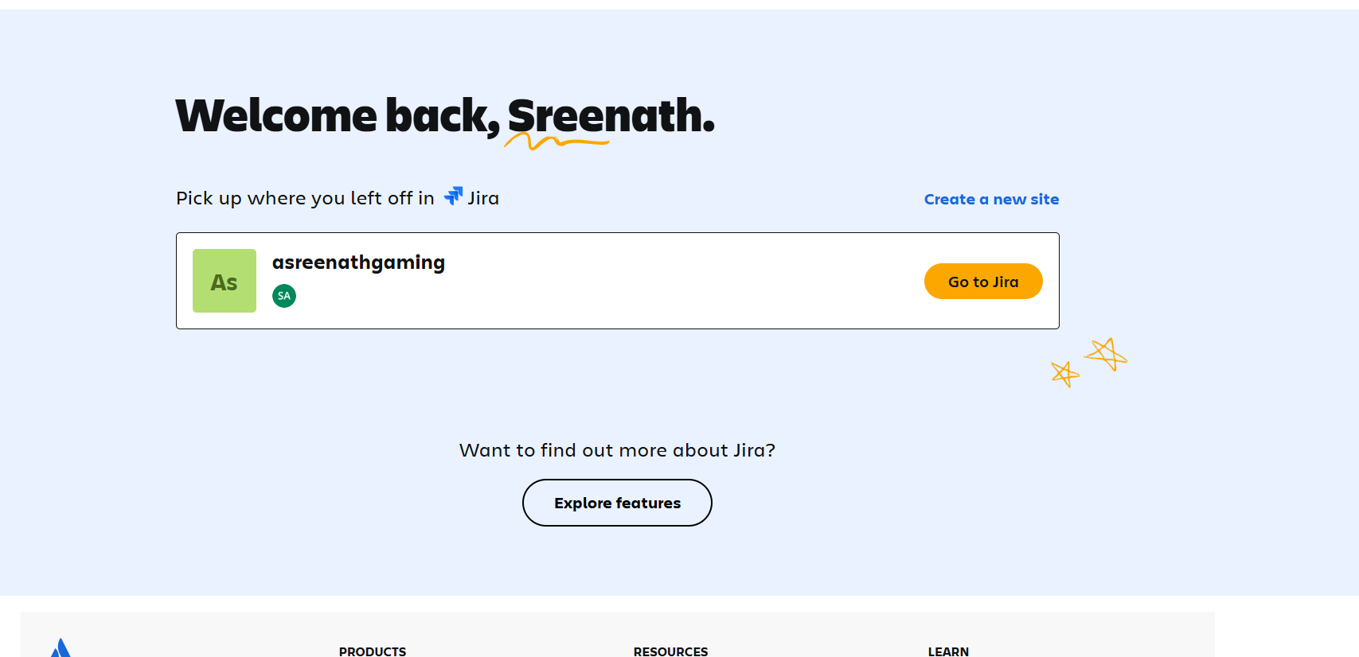

Step 2: Open Jira Software
After logging in,
- You will be redirected to the Jira dashboard.
- If prompted, select your organization/workspace.
- Wait until the Jira home page loads.
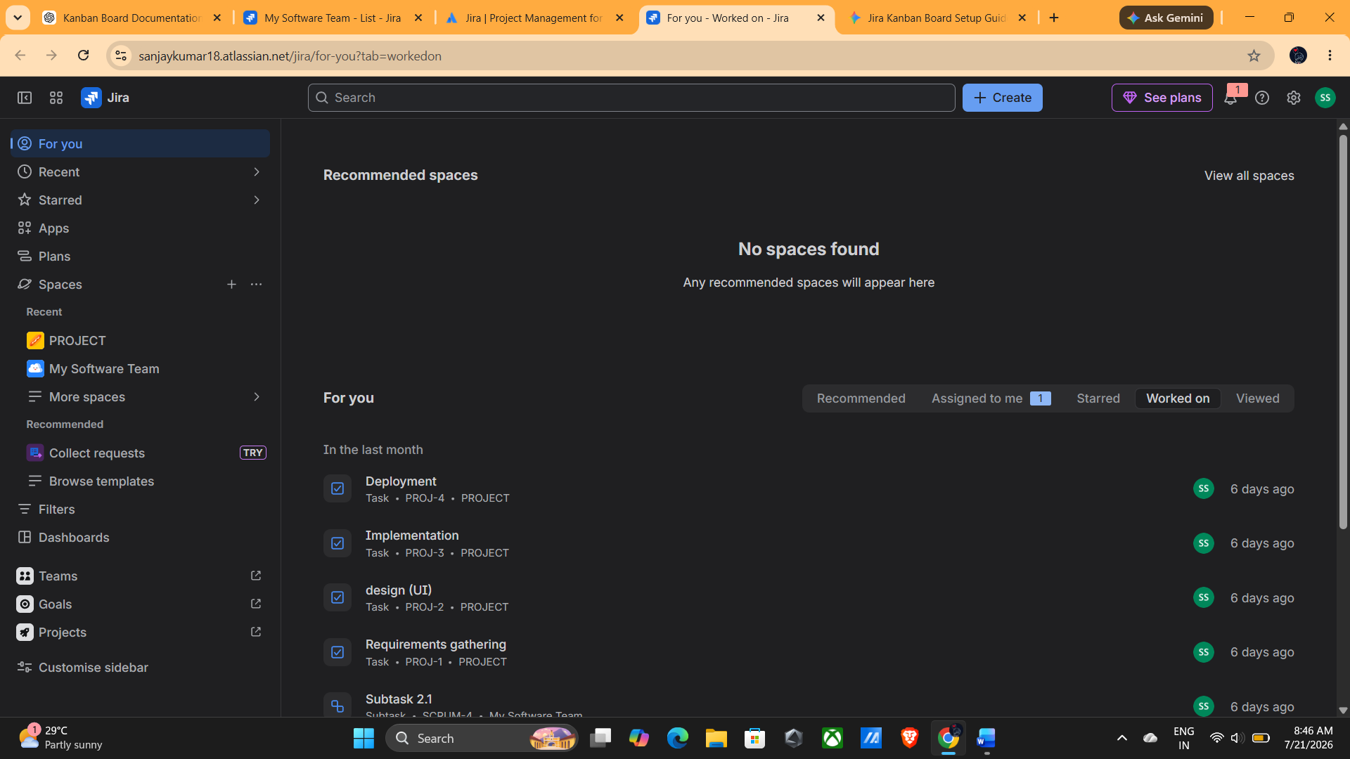

Step 3: Create a New Kanban Board
- From the Jira home page, locate the Spaces section in the left navigation panel.
- Click the + (Plus) icon next to Spaces.
- A menu will appear with different options.
- Select Kanban Board from the available board types.
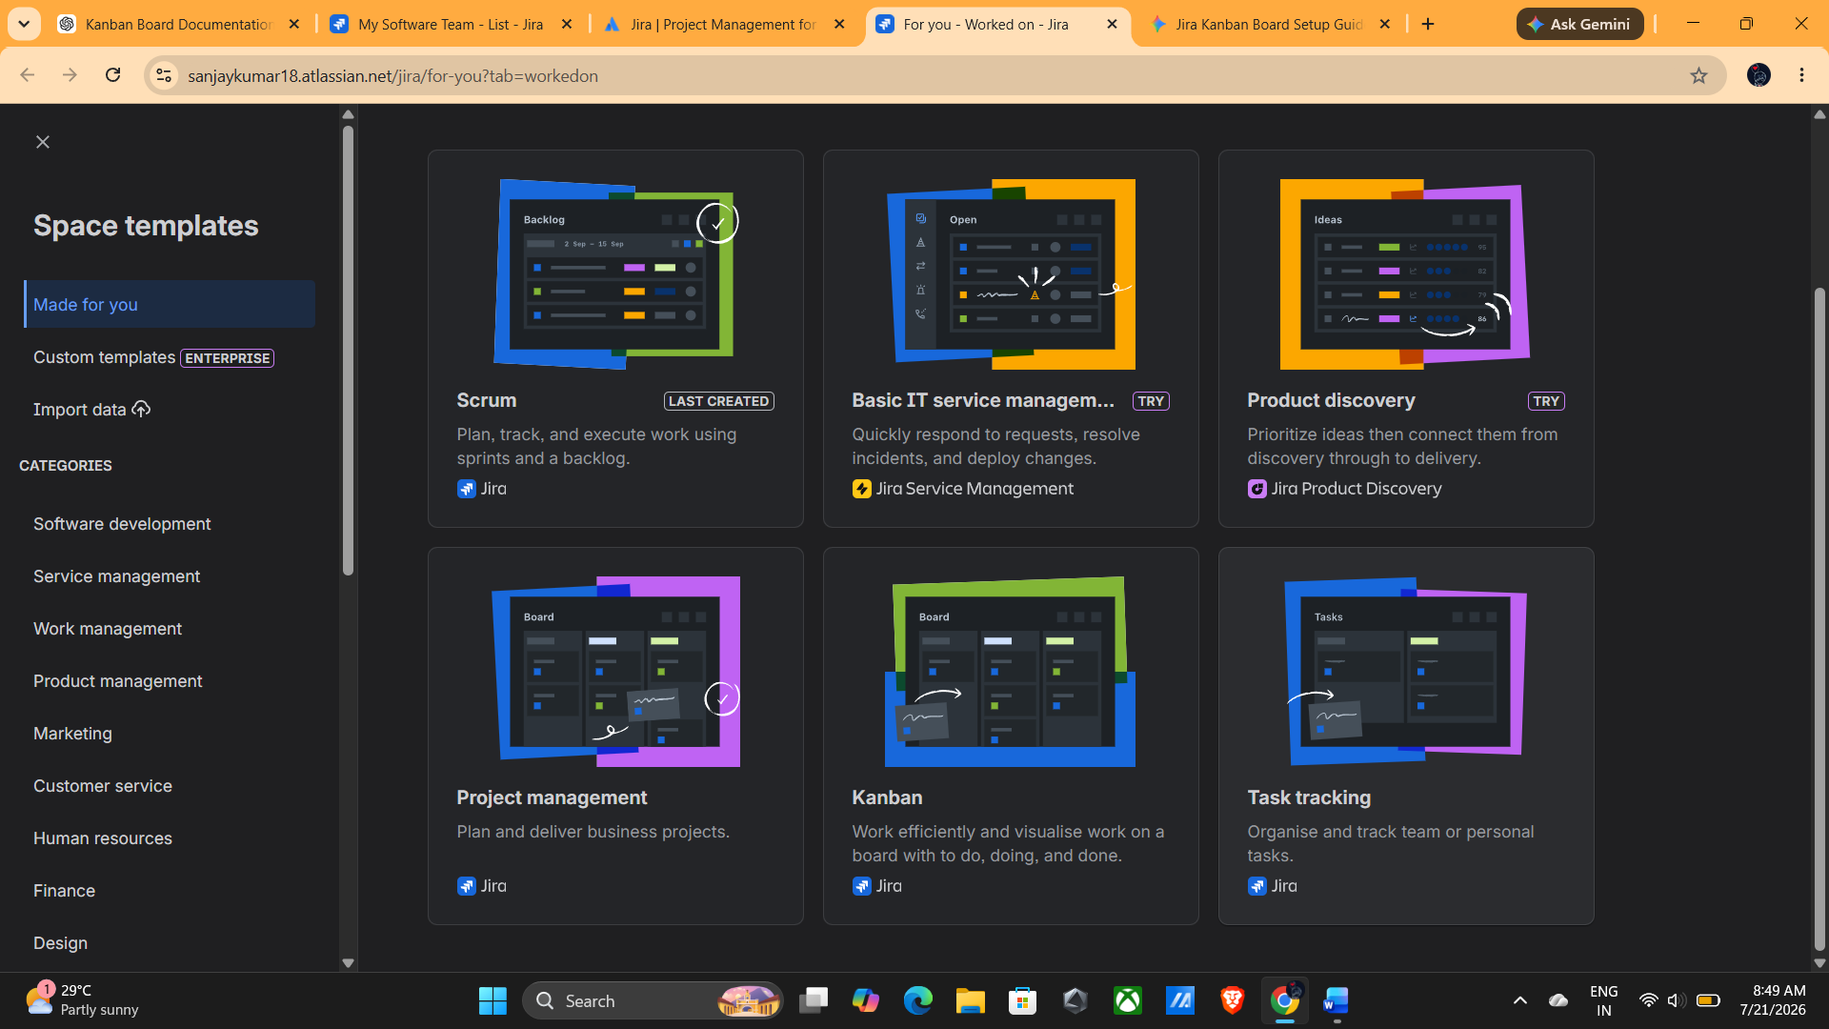
Step 4: Select Kanban Board
- After selecting Kanban Board, the board creation page opens.
- Verify that Kanban Board is selected.
- Click Use Template (or Continue, depending on your Jira version).
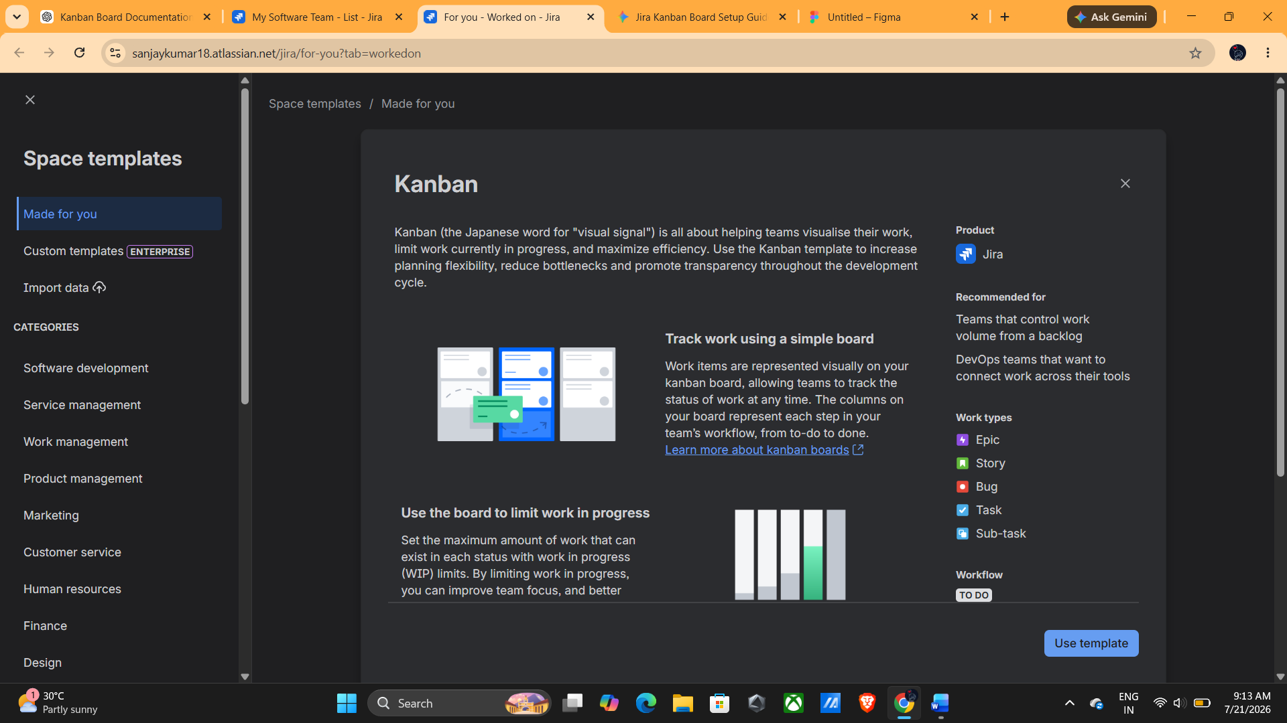
Step 5: Enter Board Details
Fill in the required details.
Space Name
Project Management (or any name required by Jira)
How your space is managed
Team-managed/ Company-Managed according to your use case
Screenshot 5: Entering Board Details and click next
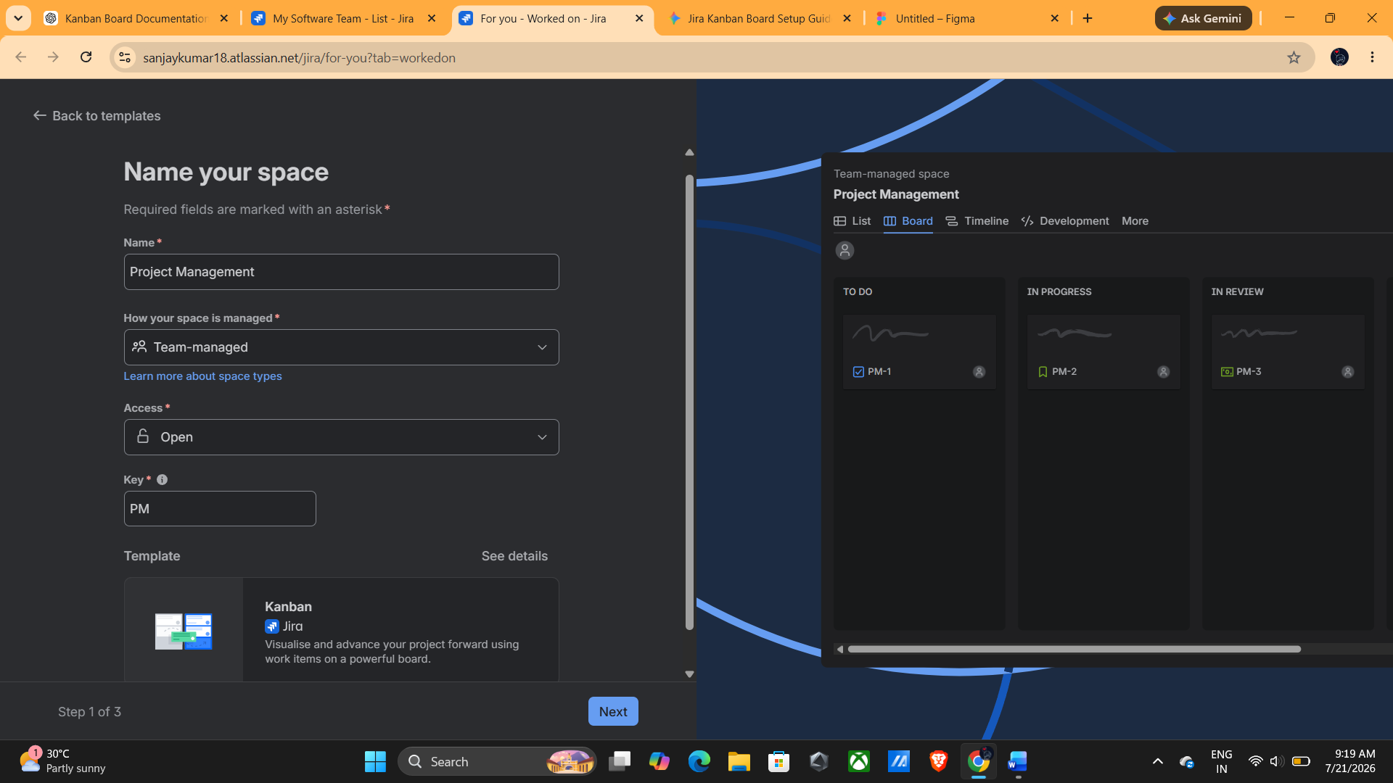
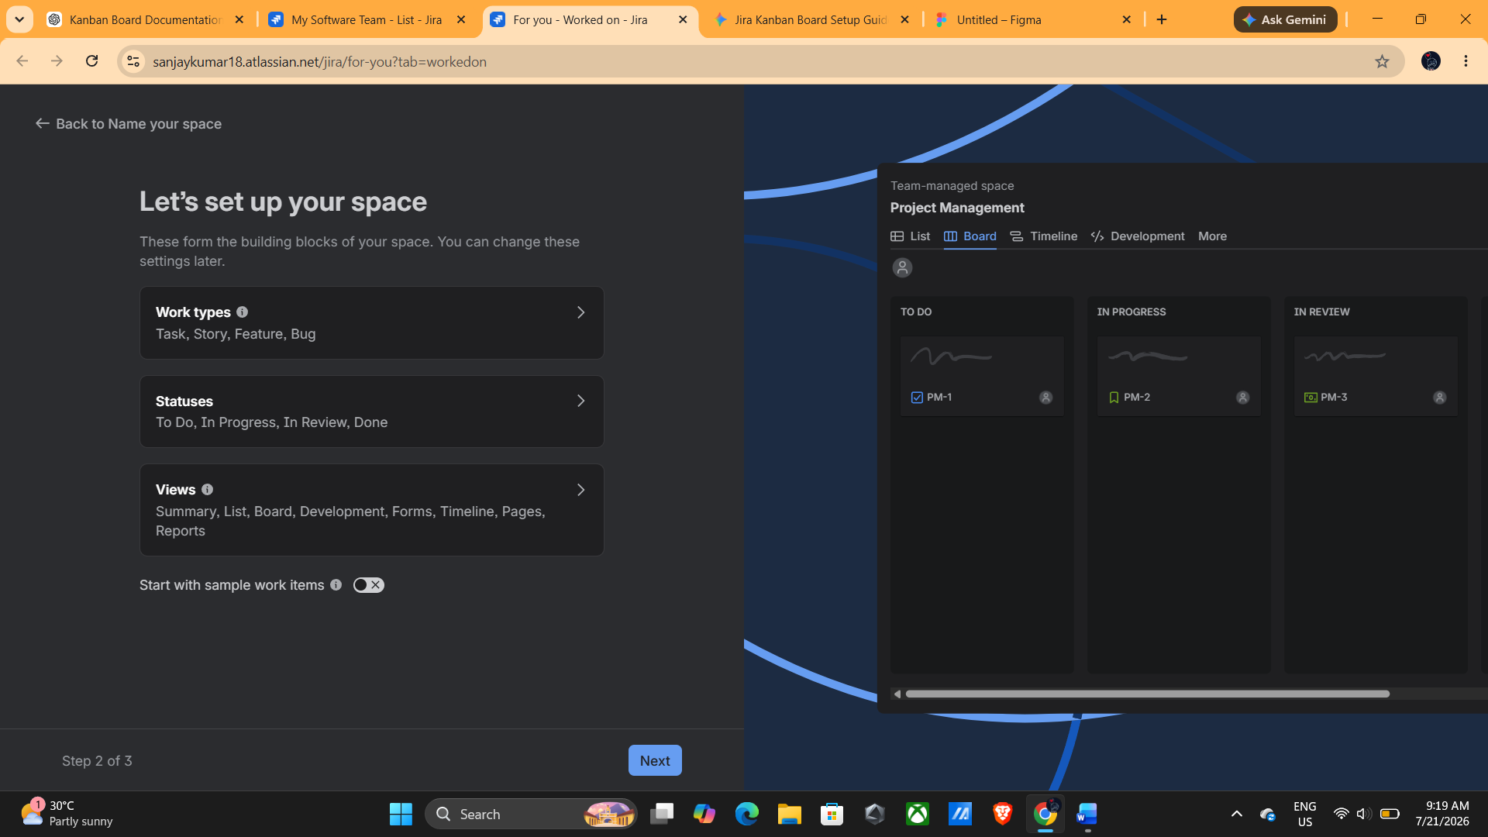
Click next and wait for a while and your space will be ready
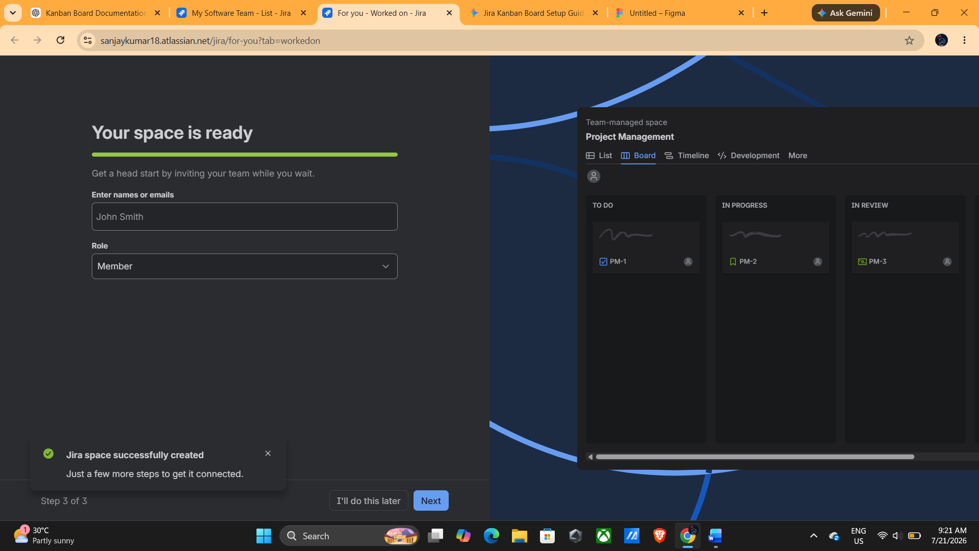
STEP 7: KANBAN BOARD
The Kanban board opens automatically.
You should see three columns:
- To Do
- In Progress
- Done
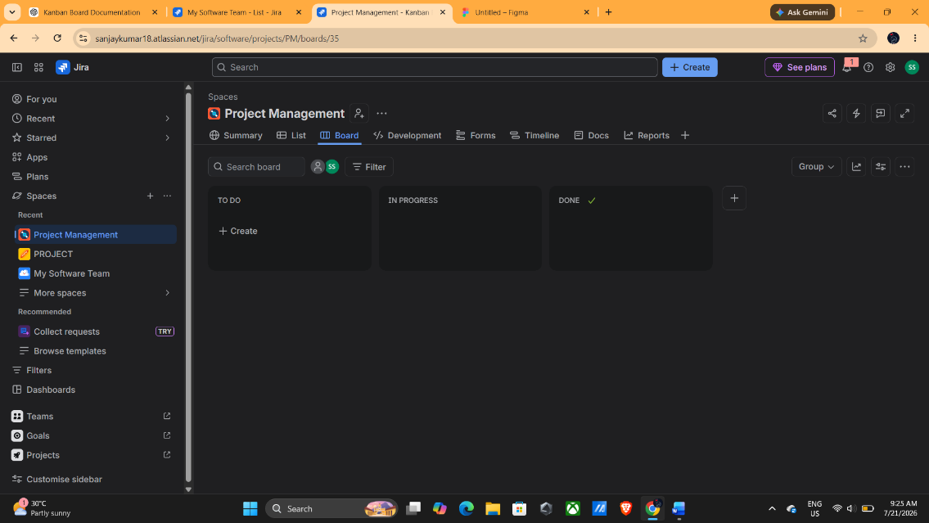
Step 8: Create the First Task
- Click Create (top navigation bar) or + Create Issue on the board.
- Choose Task as the issue type.
- Enter the following details:
Field | Value
Summary | Gather Requirements
Description | Collect client requirements and prepare project scope.
Click create
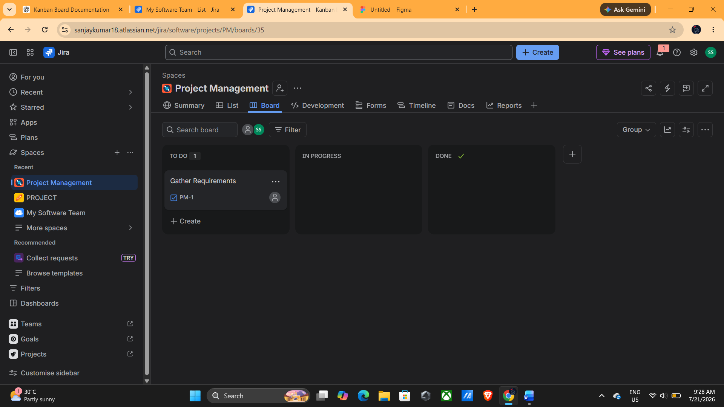
Step 9: Create the Remaining Tasks
Repeat the same procedure described in Step 8 to create the following tasks:
Summary | Description
Design UI Mockup | Prepare wireframes for application screens.
Develop Login Module | Implement user authentication.
Test Application | Perform unit and integration testing.
Deploy Project | Deploy the application to the production server.
After creating all the tasks, verify that they are displayed under the To Do column.
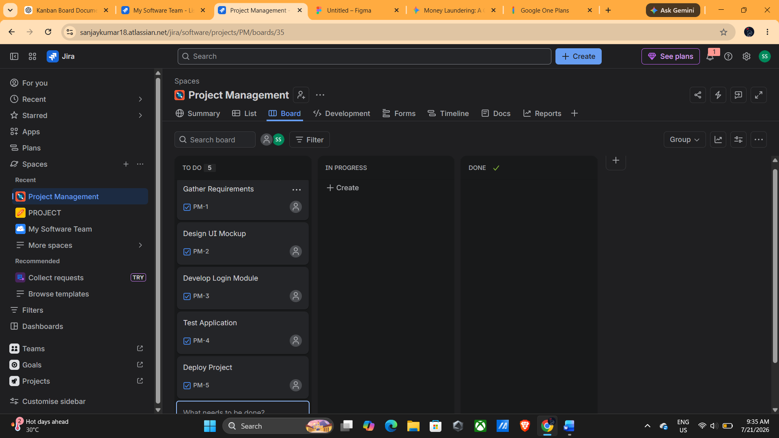
Step 10: Verify All Tasks
Return to the board.
All five tasks should appear under To Do.
Moving Tasks

Step 11: Move First Task
Click and hold
Gather Requirements
Drag it into
In Progress
Release the mouse button.
First Task in Progress 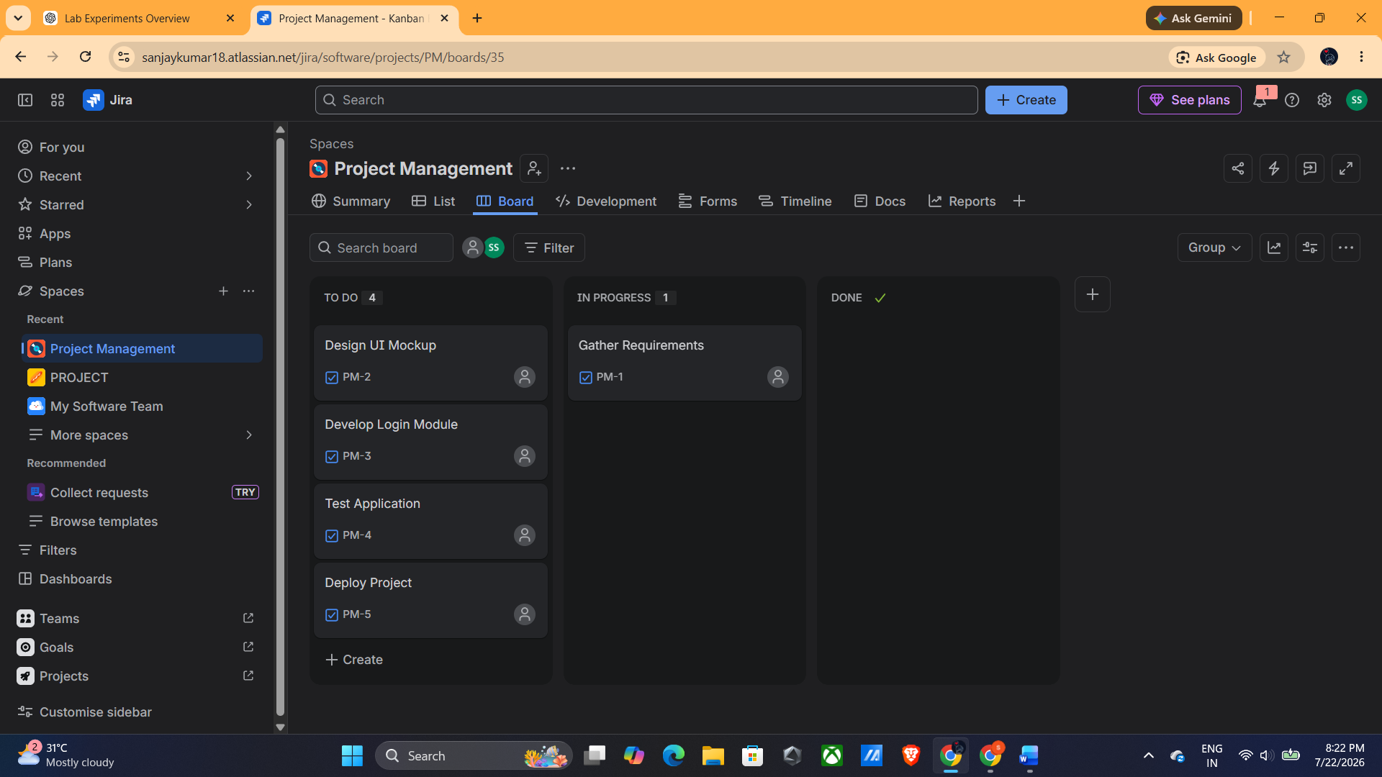

Step 12: Move Tasks to In Progress
Drag the Design UI Mockup, Develop Login Module, and Test Application tasks from To Do to the In Progress column.
Tasks Moved to In Progress
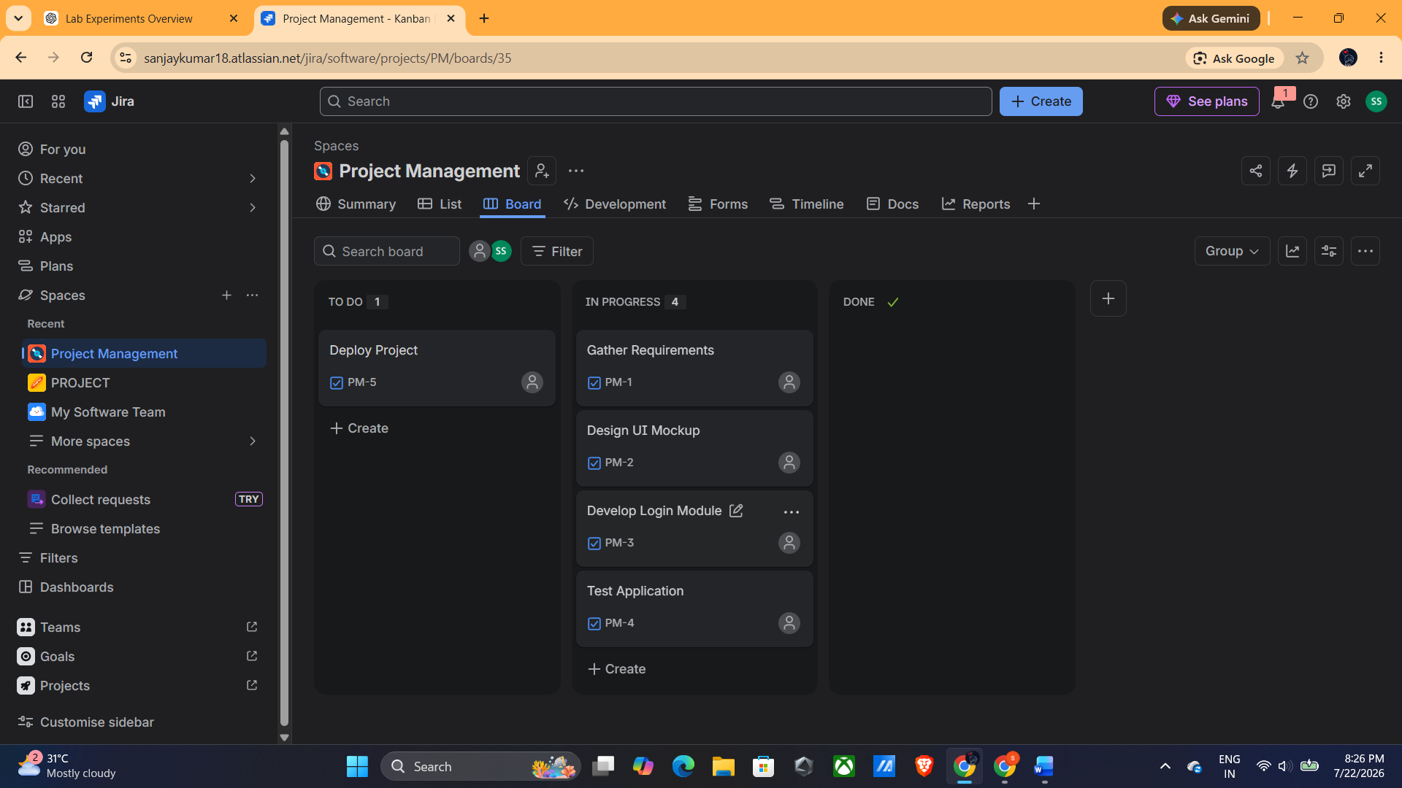

Step 13: Move Completed Tasks to Done
Drag the Gather Requirements and Design UI Mockup tasks from In Progress to the Done column to indicate their completion.
Completed Tasks Moved to Done
